7.4

Task Description #1:  
• Introduce a buggy Python function that calculates the factorial of a number using recursion. Use  
Copilot or Cursor AI to detect and fix the logical or syntax errors.  
Expected Outcome #1:  
•Copilot or Cursor AI correctly identifies missing base condition or incorrect recursive call and suggests a functional factorial implementation

Given code and Error:

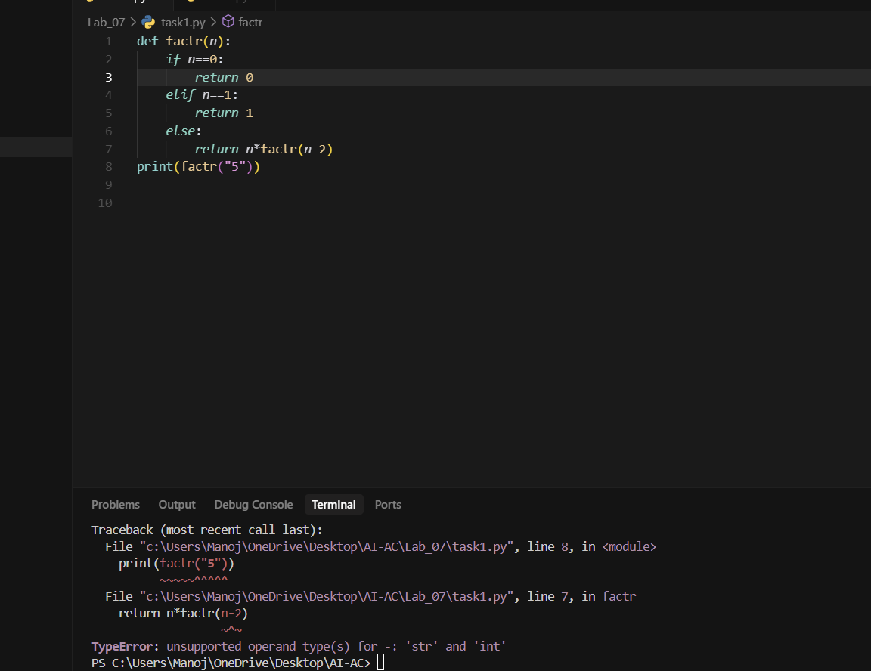

Prompt :

From the above code identify the error and fix the logical or syntax errors.

Corrected code and output:

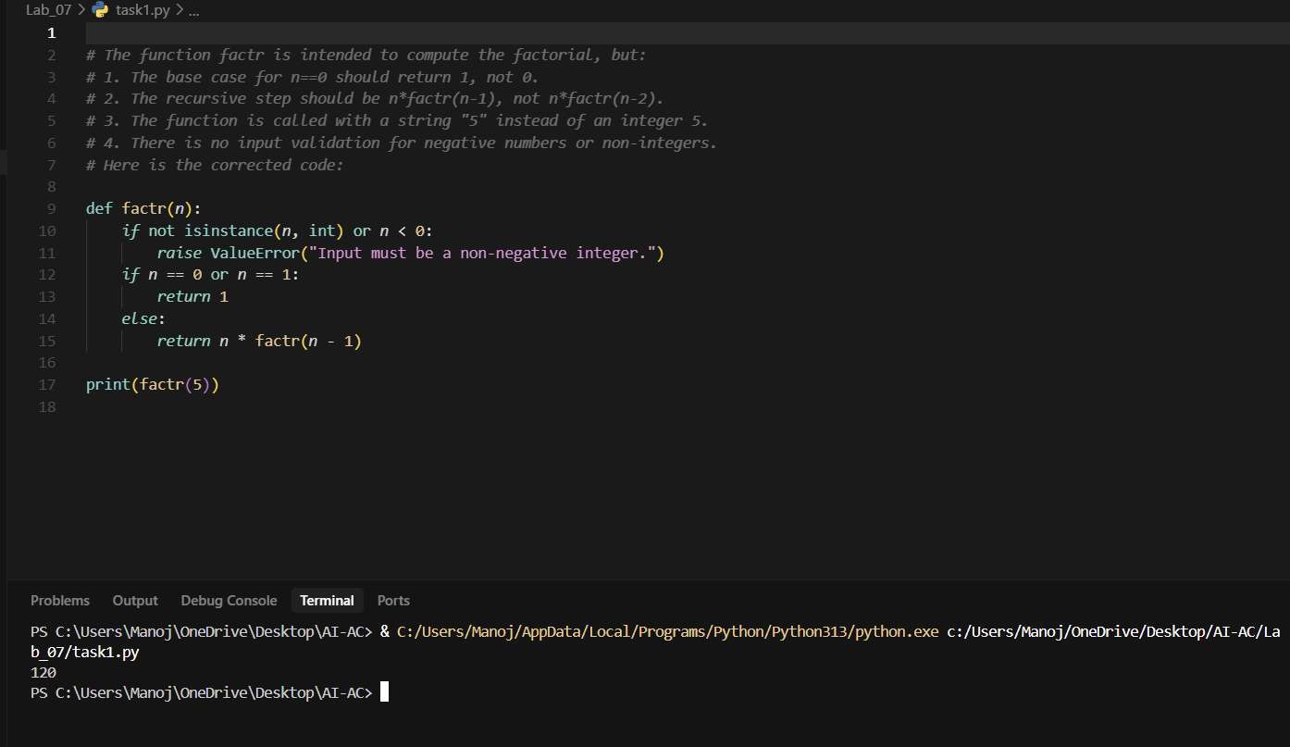

Task Description #2:  
•Provide a list sorting function that fails due to a type error (e.g., sorting list with mixed integers  
and strings). Prompt AI to detect the issue and fix the code for consistent sorting.  
Expected Outcome #2:  
•AI detects the type inconsistency and either filters or converts list elements, ensuring successful  
sorting without a crash.

Given code and Error:

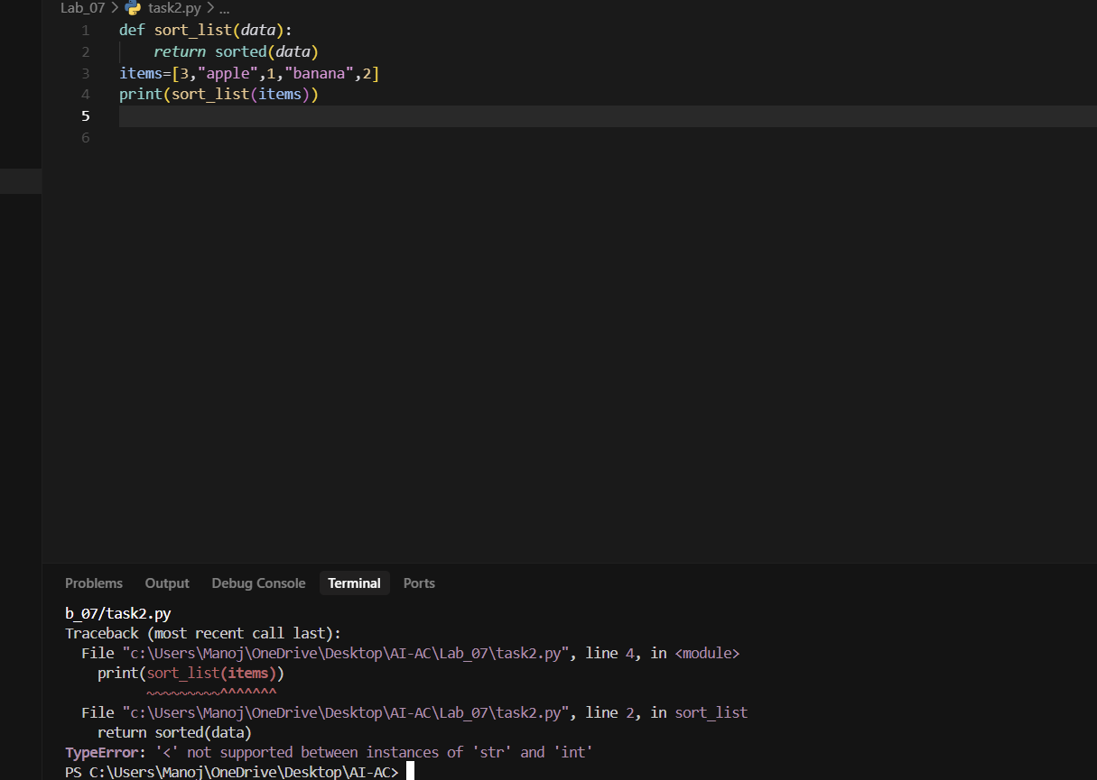

Prompt :

From the above code detect the issue and fix the code for consistent sorting.

Corrected code and its output:

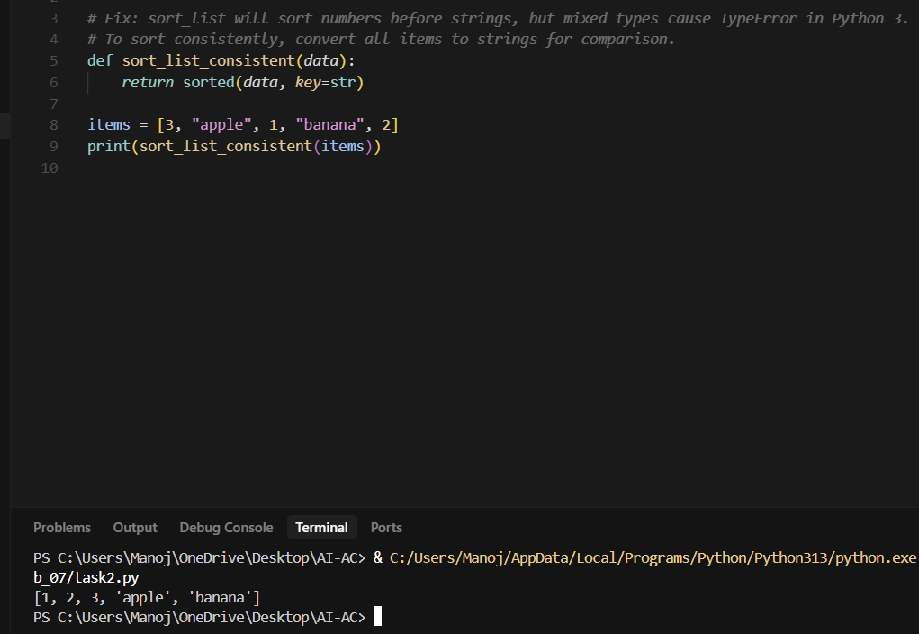

Task Description #3:  
• Write a Python snippet for file handling that opens a file but forgets to close it. Ask Copilot or  
Cursor AI to improve it using the best practice (e.g., with open() block).

Expected Outcome #3:  
• AI refactors the code to use a context manager, preventing resource leakage and runtime warnings

Given code and Error:

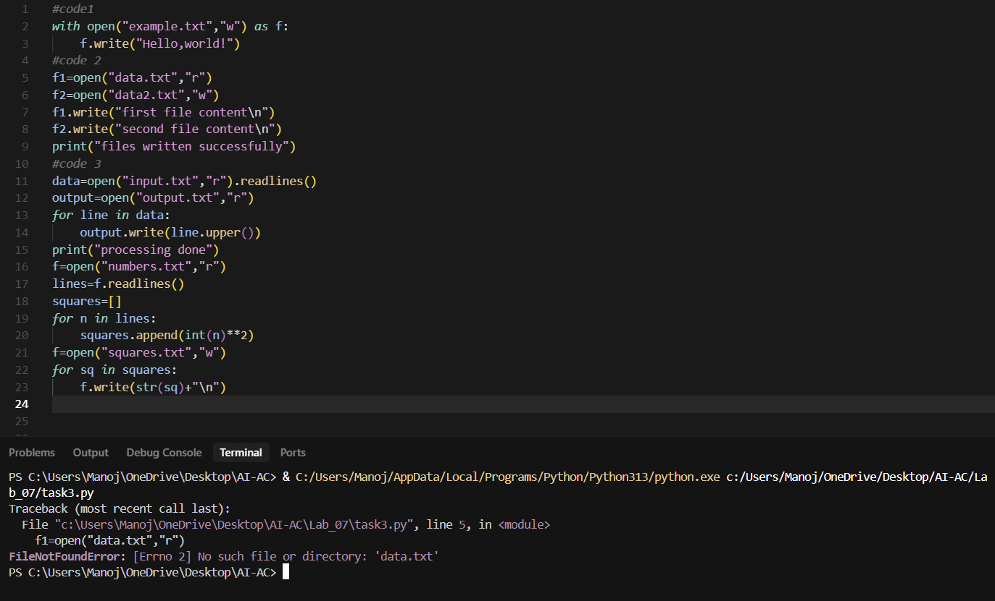

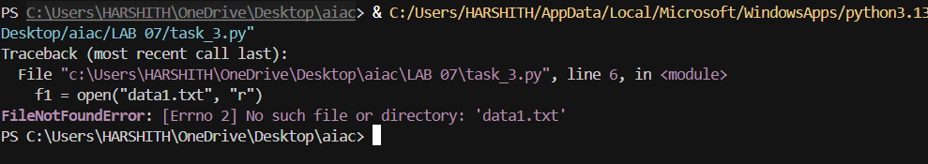

Prompt :

**Here's a Python snippet that opens a file but forgets to close it. Can you refactor it using a context manager (with open(...)) to prevent resource leakage and runtime warnings?**

Corrected code :

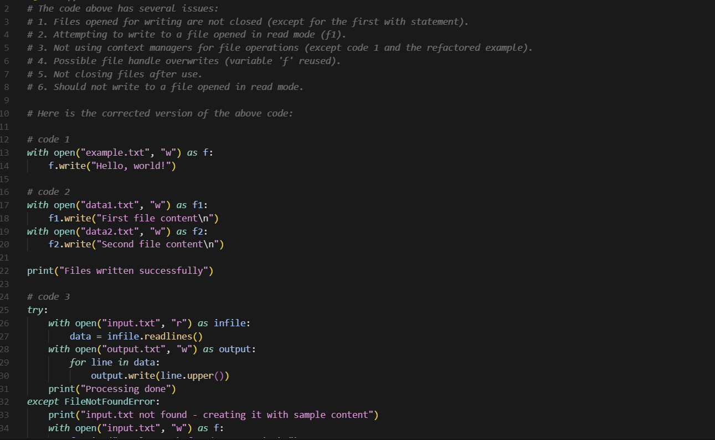

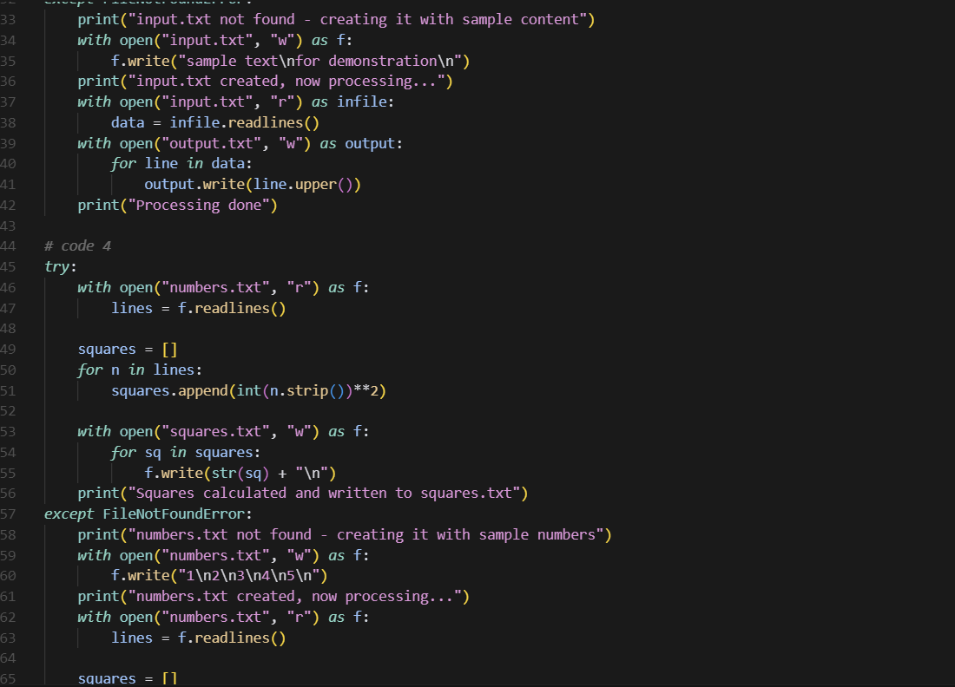

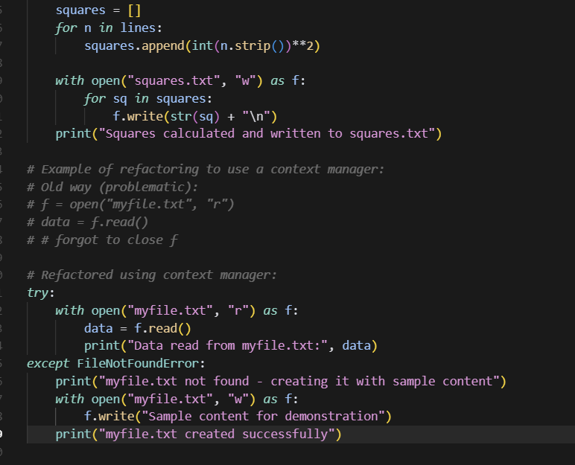

**Output :**

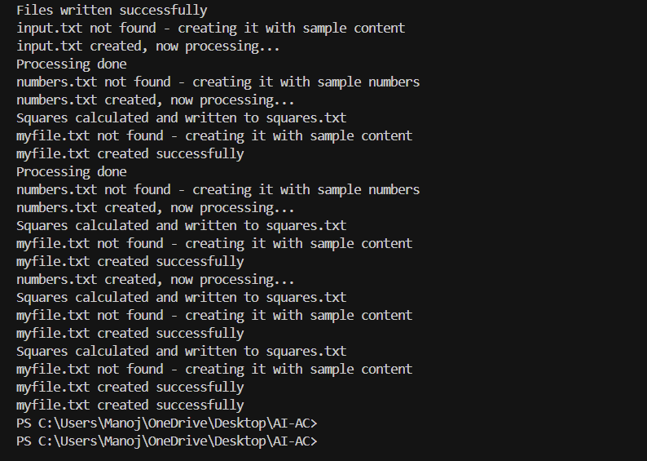

**Task Description #4:  
• Provide a piece of code with a ZeroDivisionError inside a loop. Ask AI to add error handling using  
try-except and continue execution safely**

**Expected Outcome #4:  
• Copilot adds a try-except block around the risky operation, preventing crashes and printing a  
meaningful error message**

**Given code and error:**

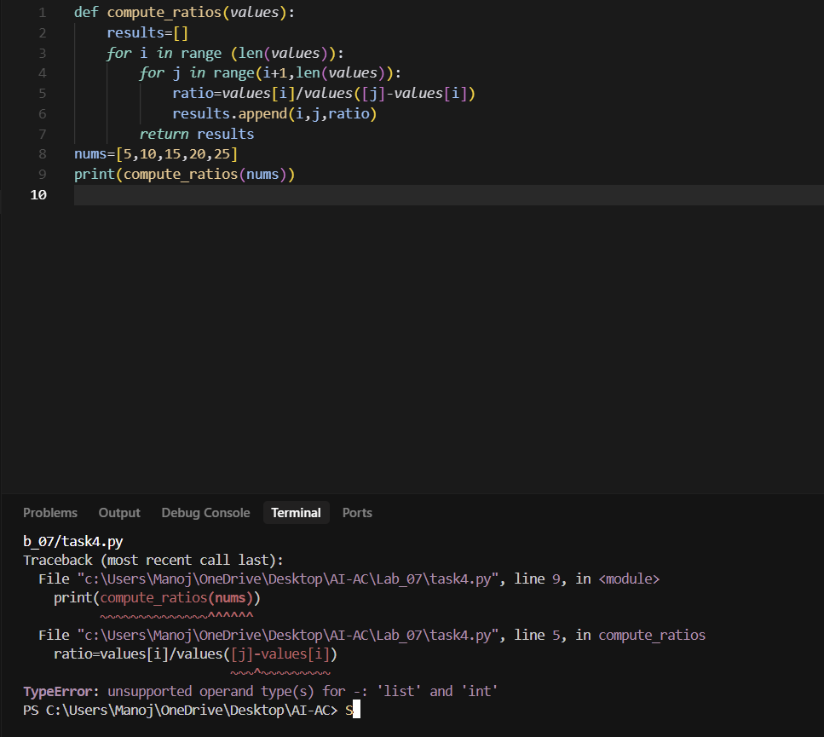

**Prompt :**

**Refactor this code to handle ZeroDivisionError using try-except and continue execution safely**

**Modified Code and output:**

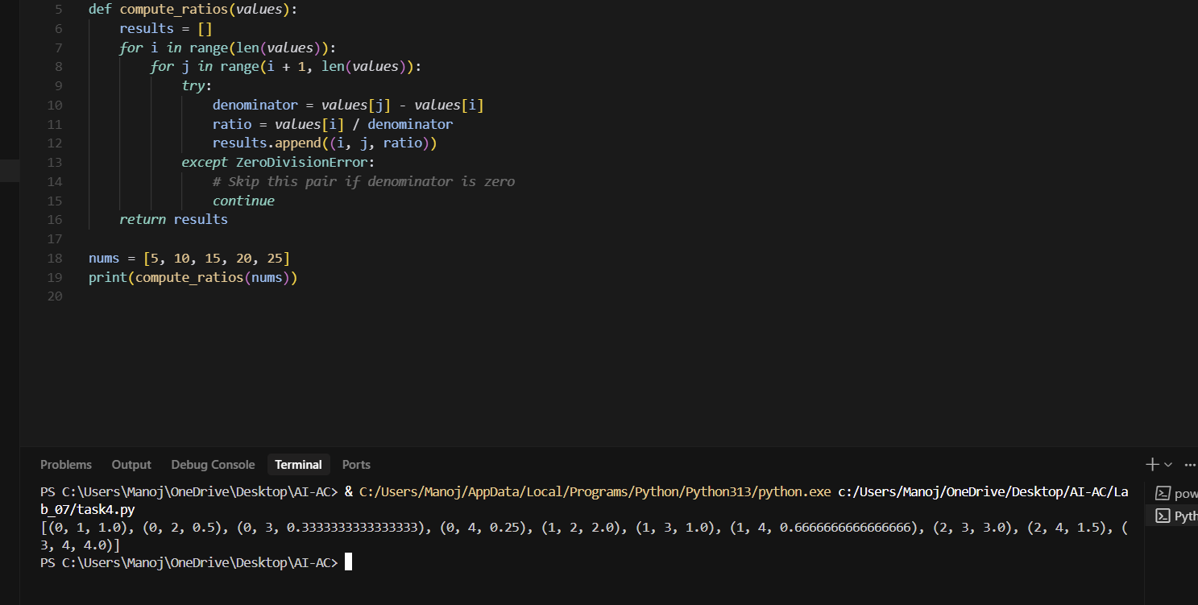

**Task Description #5:  
• Include a buggy class definition with incorrect __init__ parameters or attribute references. Ask AI  
to analyze and correct the constructor and attribute usage.**

**Expected Outcome #5:  
• Copilot identifies mismatched parameters or missing self references and rewrites the class with accurate initialization and usage.**

**Given code and Error:**

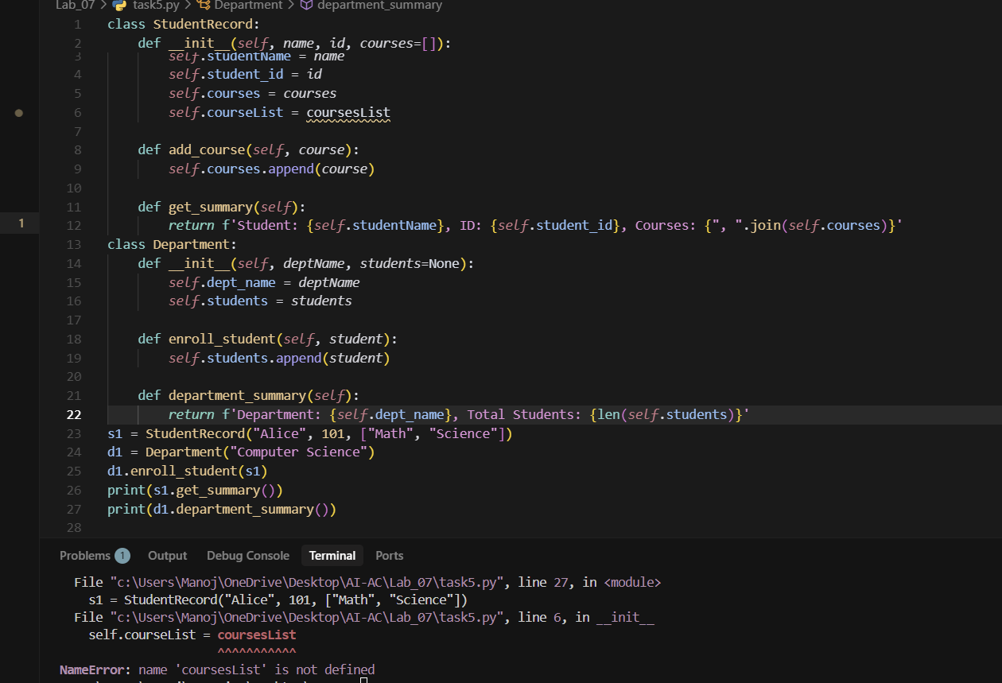

**Prompt :**

**Analyze the error and fix it with a corrected version**

**Corrected Code and output:**

